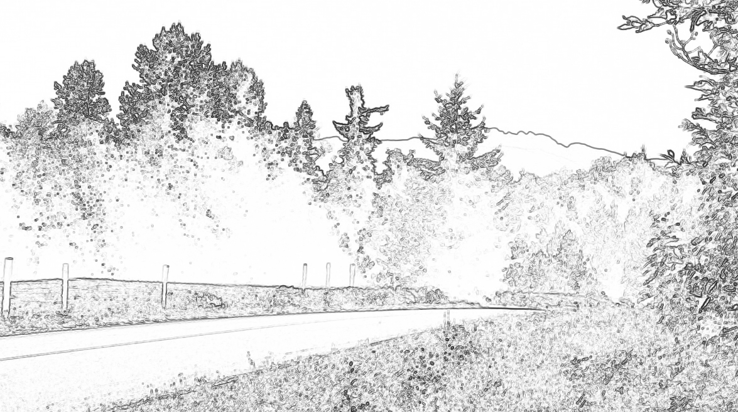

IMPORTANT INFORMATION THAT AFFECTS ALL RESIDENTS!

The Corcan-Meadowood Residents Association has recently learned that we have lost funding promised to us by the RDN and POSAC. This funding was designated for developing a community park and playground in our village center (located behind the Meadowood store near the fire hall). The promised funding was redirected to the Errington/Coombs community (also in area F) which has 2 schools (containing playground equipment) and 3 parks. Our only park area is Little Qualicum River Falls, but there is no playground equipment.

This affects all residents! Families with young children as well as residents who have visitors with young children.

Our plan is to contact the RDN and POSAC to advise them that we deserve these funds.
We are a newer community experiencing rapid growth and we anticipate another 300 homes in the area over the next several years.

We are asking for your support by supplying us with information which will be presented to the RDN and POSAC. Please complete and drop off at the Meadowood Store or the Home Tek office located within Little Qualicum Village by Friday June 17th.

Resident Name ____________________________________________________________________

Children’s Names (optional) and ages
__________________________________________________________________________________

Address __________________________________________________________________________________

Phone numbers __________________________________________________________________________________

E-mail __________________________________________________________________________________

We will keep you informed by E-mail.

Questions? Call Elaine Peligren @ 250-816-3130 or Alf Jablonski @ 250-752-7119

